2020 LEEF Pilot Program Participant Survey Results
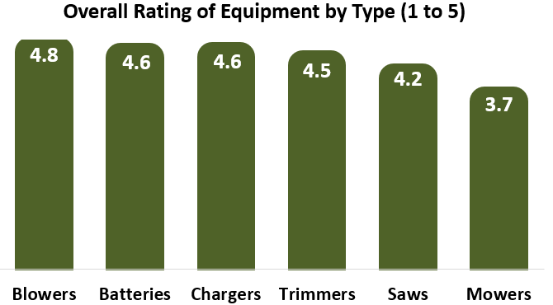
The participants are experiencing both benefits and challenges using their new electric equipment. The most common benefits are that the electric equipment is quiet, effective, produces no exhaust, does not require refueling, and is easy to use. The largest challenge mentioned was the frequency and length of time required to recharge the equipment’s batteries.
On June 30th, the District sent a survey to participants of our pilot program to receive feedback about their operation of the electric landscape equipment and how the LEEF program can be improved in the future. Thirteen out of 17 program participants responded. Overall, satisfaction with the electric equipment is rated highly on a scale of 1 to 5, with 5 being the highest. Blowers are the most highly rated equipment type at 4.8 and mowers are rated the lowest at 3.7. Some participants have trouble operating their mowers on wet or hilly turf.
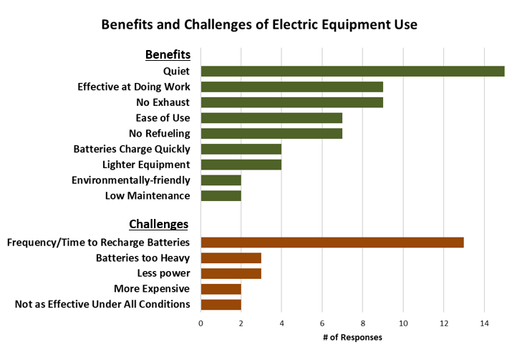
Participant Ideas to Improve Program:
- More advertising
- Host event for organizations to try out different electric equipment
- Include disposal of gasoline equipment as part of program
- Batteries AND chargers should be free (program funded 1 free battery OR charger per piece of equipment purchased)
- Offer higher grant amounts for larger businesses/organizations
- Streamline assessment of award amount
The participants provided ideas to improve the program that we are taking into consideration while we develop a proposal for Year 2 of the LEEF Program.

We received some great testimonials about participants’ experiences with their new equipment.
“The electric landscape equipment has been a game changer for us. Our customers and employees appreciate the quiet, clean, and extremely efficient tools. The batteries are comfortable to wear, charge quickly and fully, and last through the day. No more oil mixes, spills, fumes, and trips to the gas station to fill our cans! This is the wave of the future and I highly recommend these!”
- Deborah Shaw Restoration + Landscape, INC. (Santa Barbara)

“Midland school with the help of this program is making the change to a cleaner future one piece of equipment at a time.”
- Midland School (Los Olivos)

“We are pleased that we were provided the funds to purchase four battery operated landscape items with the necessary batteries and chargers. All the equipment has been put to good use. We are doing our bit to improve the environment with the use of these tools. Thank you for providing funding for the battery-operated tools and for the batteries”
-St. Andrew’s Preschool (Santa Barbara)

“The electrical equipment is cleaner and not as smelly.” - Landscapes by David (Santa Barbara)

“Surprised how powerful the equipment is.” - Nomura/Yamasaki Landscapes, Inc. (Goleta)

Most of the participants have removed at least some of their gasoline equipment from service and replaced it with electric equipment. Some organizations are saving gasoline equipment to use as backup, or when needed due to specific job constraints. Most participants report that they still have some gasoline equipment in service. So far, our program has helped one organization go completely electric. All but one participant is interested in participating in the program again in the future, to purchase more electric equipment.
Survey Responders Say…
10 out of 13 have taken gasoline equipment out of service
1 out of 13 has gone completely electric
12 out of 13 would participate in the program again

