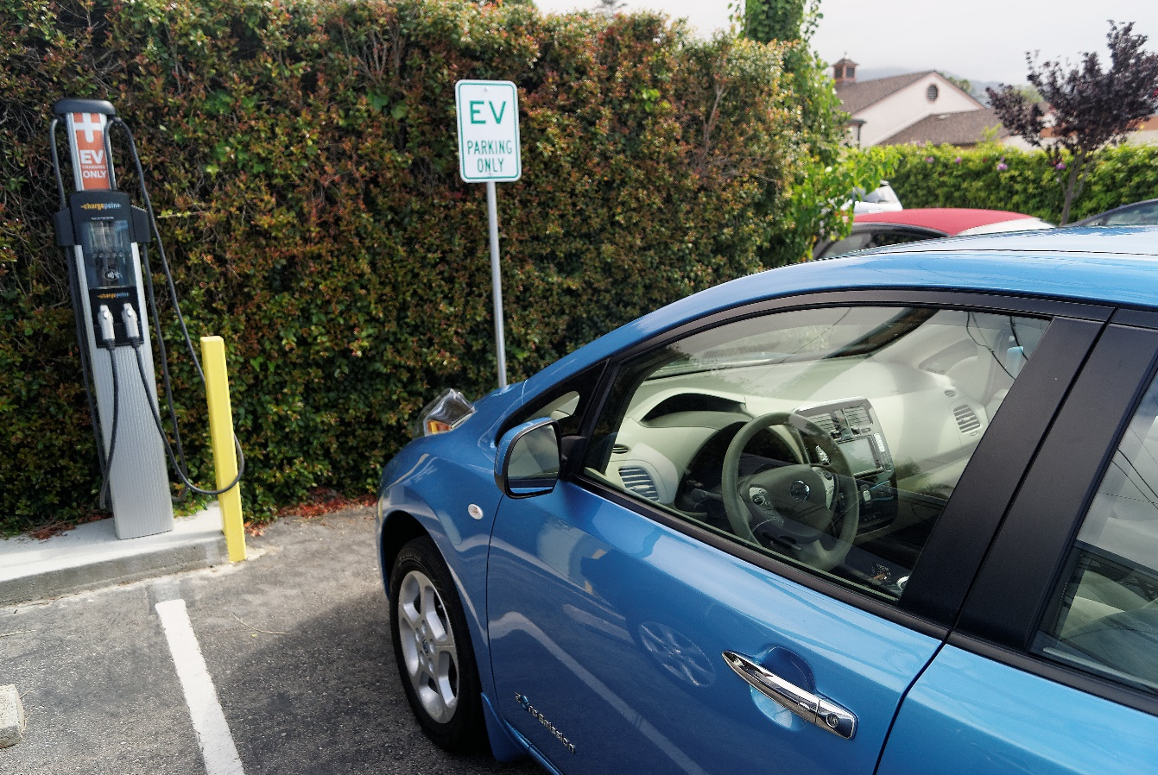

# Frequently Asked Questions

# Protecting Our Air

*The Santa Barbara County Air Pollution Control District (District) is a local government agency that works to protect the people and the environment of Santa Barbara County from effects of air pollution.*

*We are an independent special district, responsible for controlling air pollution from business and industry sources (we do not regulate motor vehicles). Our jurisdiction covers the entire County, including the incorporated cities of Buellton, Carpinteria, Goleta, Guadalupe, Lompoc, Santa Barbara, Santa Maria, and Solvang.*

# Visit [www.OurAir.org](http://www.OurAir.org)

* *View Today’s Air Quality*
* *Find out about funding programs*
* *Subscribe to our newsletter, and to   
  Air Quality Advisories*
* *Access permitting and compliance info*
* *Find out what you can do for cleaner air*

# Phone Numbers

Main Number 961-8800

*(general information and complaints)*

Public Information & Media 961-8819

Business Assistance 961-8868

Recorded Information 961-8802  
*(today’s air quality in English and Spanish, general information, breakdown reporting)*

Congue nihil imperdiet doming id quod mazim placerat facer minim veni am ut wisi enim ad minimeniam, quis erat nostr uexe

rci tation ullamcorper nostru exerci tation ullam corper et iusto odio dig nissim qui blandit praesent lupta. Tummer delenit

augue duis dolore te feugait nulla facilisi. Con erattis sectetuer adip iscing elit, sed erat diam nonummy nibh magna erat.

C:\Users\mjl\Desktop\images\qr codes\ourair_webpage.png­­­

***Q:******Do I have to pay more for a car that’s better for our air?***

**A:** Not necessarily. Dealers today offer a range of less-polluting, fuel-efficient models, and there are a variety of cash incentives and lease packages for zero-emission vehicles. You may be able to find a very low-emission version of your favorite vehicle model – and driving a more fuel-efficient car will reduce fuel costs.

***Q: Should I get a hybrid, a plug-in hybrid, a battery-electric, or a fuel-cell vehicle?***

**A:** After you determine your budget and the type of vehicle you want, compare by air emissions, fuel efficiency, driving range, and other factors important to you. Hybrids are fuel-efficient, but so are many gas-powered cars. Battery-electric vehicles, plug-in hybrids, and fuel-cell vehicles are good options for our air and for our planet.

***Q: Do Sport Utility Vehicles, minivans, and trucks have different emissions standards than cars?***

**A:**No. As of 2004, the Environmental Protection Agency requires these vehicles to comply with the same national pollution standards as cars. However, there are significant differences between vehicles in these categories, and there are some large electric and hybrid vehicles available. Compare pollution and fuel efficiency ratings.

260 N San Antonio Rd, Suite A  
Santa Barbara, CA 93110  
(805) 961-8800

**www.OurAir.org**

***About Our Air***

***Clean-Air Cars***

* ***Hybrids and Plug-in Hybrids***
* ***Low Emission Gasoline Cars***
* ***All Electric***

**www.OurAir.org**

# What’s Ahead?

**More Things to Consider**

**Clean-Air Cars**

* **Look for a newer model**

Brand-new models have to meet the strictest standards. If you are looking at a used car, look for one six years old or newer.

* **Look at the fuel efficiency rating as well as**

**the air pollution rating.**

The two don’t always go hand in hand, but fuel-efficient cars are often also less polluting. The better the fuel economy, the less production of carbon dioxide, a greenhouse gas that contributes to global climate change.

Cars and trucks are a major source of smog-forming pollution in Santa Barbara County. They also emit greenhouse gases, which contribute to global climate change. The best thing you can do for our air is to **drive less** – walk, bike, carpool, combine car trips, or take the bus whenever you can. Try telecommuting.

When you do drive in your current vehicle, combine car trips, carpool, keep your car tuned up and your tire pressures up, and don’t top off your tank at the gas station – stop fueling when the pump shuts off.

If you’re in the market to buy a vehicle, buying a clean-air car is another step to help keep our air clean. Whether you are doing web research ahead of time, talking to friends, making some phone calls, or visiting car dealerships, there are several things to consider.

We are living in an exciting time for clean vehicle technologies.

In the next few years, automakers will be offering more all-electric (also known as battery-electric) and plug-in hybrid electric vehicle models, with increased driving ranges. Even accounting for the emissions associated with the electricity for charging the batteries, EVs are considered much cleaner than their gasoline counterparts. The State notes that EV-charging costs typically come in below gasoline costs for gasoline vehicles.

Hydrogen Fuel Cell Electric Vehicles (FCEVs) are zero-emission vehicles and run on compressed hydrogen that is processed in a fuel cell to produce electricity. By 2020, automakers expect to make FCEVs widely available to California consumers.

The District is working with partners in the community to improve public EV-charging infrastructure in Santa Barbara County, as well as regionally. For more information, see www.ourair.org/ev-charging-program or contact Jim Fredrickson at (805) 961-8892.

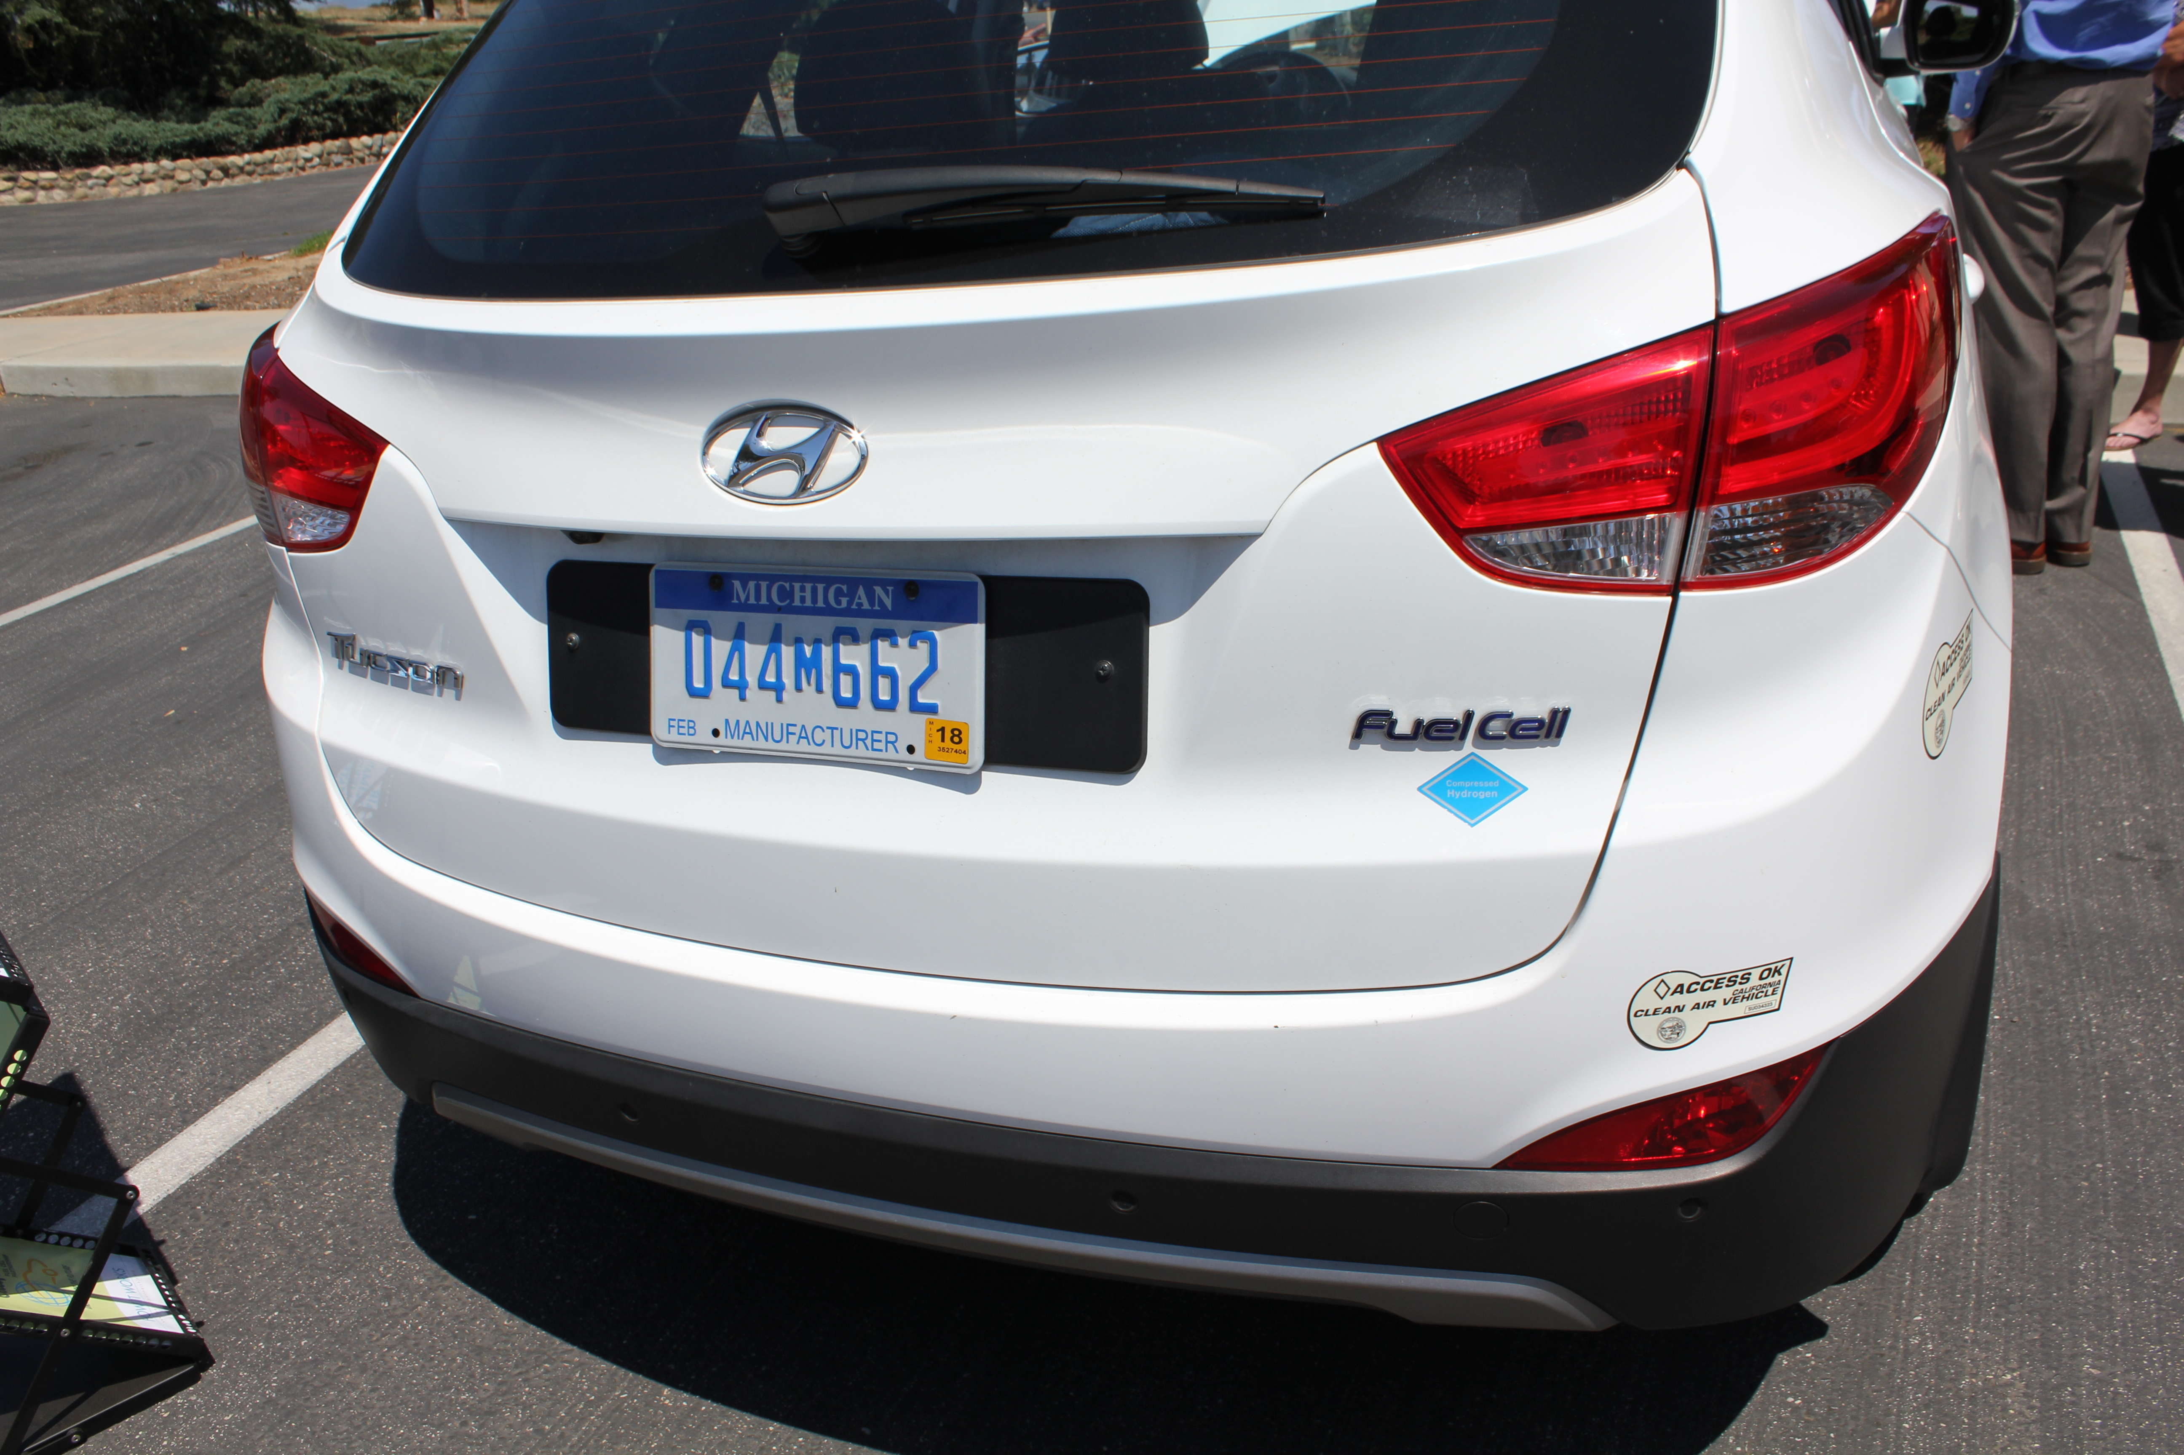

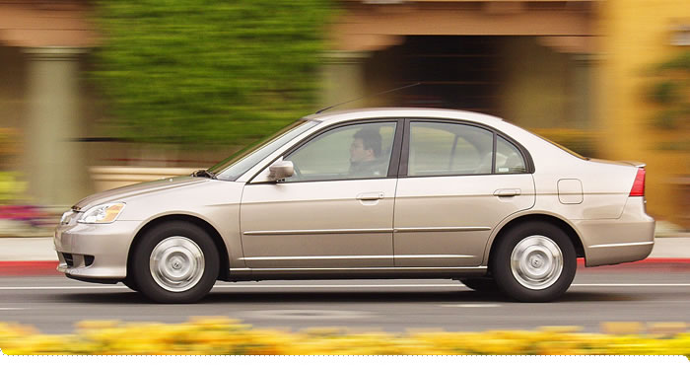

* **Check the Fuel Economy and Environment label on the car (see below)**

This label provides a smog rating, and a rating for fuel economy and greenhouse gas emissions.

**Things to Consider…**

*This Hyundai Tucson Fuel Cell vehicle is one of the most futuristic vehicles on the road. While it performs just as well as an internal combustion engine, its only tailpipe emission is water.*

# You Can Learn More…

* **California Air Resources Board’s Guide to Cleaner Cars:** [**www.driveclean.ca.gov**](http://www.driveclean.ca.gov)The latest on the cleanest cars on the road, including electric models, gas-electric models, and new technology cars that will be available in the future.
* **California Fuel Cell Partnership:** [**www.cafcp.org**](http://www.cafcp.org)
* **Electric Vehicle Collaborative:**

[**www.evcollaborative.org**](http://www.evcollaborative.org)

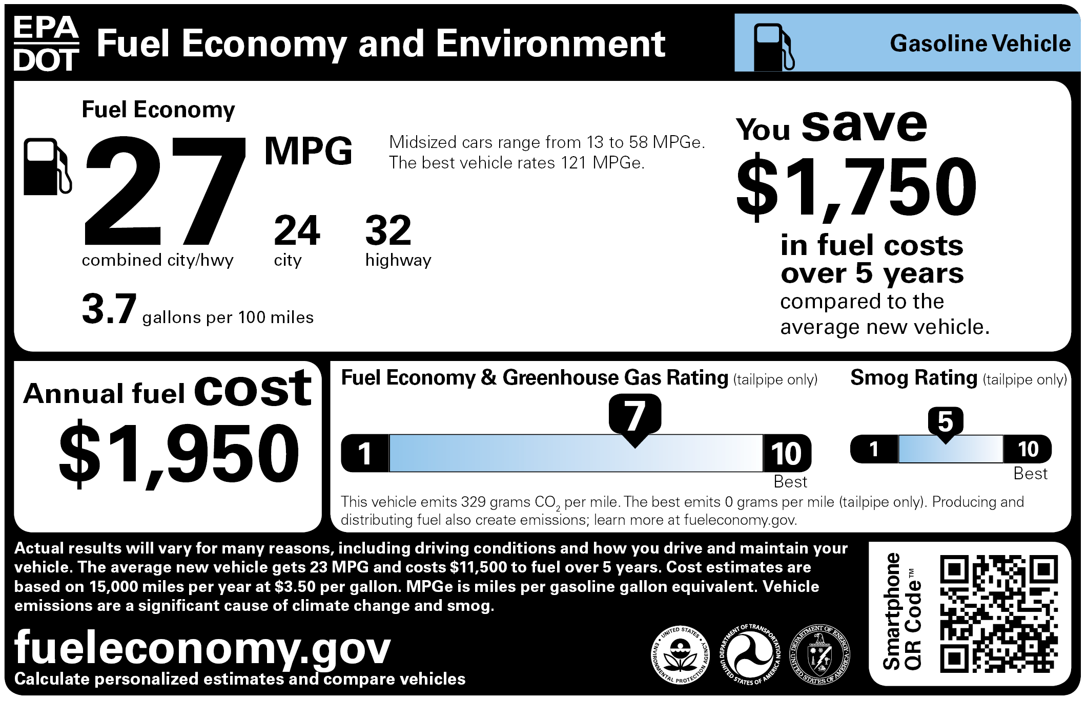

# True or False?

**The bigger the vehicle, the safer it is.**

Not always true. There are different ways to evaluate the safety of vehicles. For example, some smaller vehicles are safer in something called “crash avoidance,” the ability to avoid serious accidents, than bigger vehicles.

